
SharePoint Framework (SPFx) development environment (step by step)
For SharePoint Developer (SPFx)


December 17, 2020
Zurich/Farmers
Zurich insurance group ltd. Is a swiss insurance company, commonly known as Zurich, headquartered in Zürich, Switzerland. The company is Switzerland’s largest insurer.
Address: Zurich North America, 1299 Zurich Way, ZAIC, Schaumburg, IL 60196, United States

Table of Contents
- Table of Contents 2
- Version History 3
- Overview of the SharePoint Framework 4
- Why the SharePoint Framework? 4
- JavaScript injection 4
- SharePoint Add-in model 5
- SharePoint Framework 5
- SharePoint Framework License 5
- Prerequisite for SPFx Development 5
- Install NodeJS 5
- Install Code editor 6
- Install Yeoman and gulp 6
- Install Yeoman SharePoint generator 7
- Install Trusting the self-signed developer certificate 7
- Postman and Fiddler (Optional) 7
- Create the Web part project 7
- Create First Hello World Client Web part 7

Version History

Version# | Modified by | Date | Comments
1.0 | Priye Rakshakar | 12/17/2020 | Up to date documentation on how to submit requests across different source systems
2.0

Overview of the SharePoint Framework
The SharePoint Framework (SPFx) is a page and web part model that provides full support for client-side SharePoint development, easy integration with SharePoint data, and extending Microsoft Teams. With the SharePoint Framework, you can use modern web technologies and tools in your preferred development environment to build productive experiences and apps that are responsive and mobile-ready.
The latest version, and all previous versions, of the SharePoint Framework are hosted and available in SharePoint Online. It's also available for SharePoint Server 2016 (with Feature Pack 2) and SharePoint Server 2019.
Key features of the SharePoint Framework include:
- It runs in the context of the current user and connection in the browser. There are no iFrames for the customization (JavaScript is embedded directly to the page).
- The controls are rendered in the normal page DOM.
- The controls are responsive and accessible by nature.
- It enables the developer to access the lifecycle in addition to render, load, serialize and deserialize, configuration changes, and more.
- It's framework-agnostic. You can use any JavaScript framework that you like including, but not limited to, React, Handlebars, Knockout, Angular, and Vue.js.
- The developer toolchain is based on popular open-source client development tools such as NPM, TypeScript, Yeoman, webpack, and gulp.
- Performance is reliable.
- End users can use SPFx client-side solutions that are approved by the tenant administrators (or their delegates) on all sites, including self-service team, group, or personal sites.
- SPFx web parts can be added to both classic and modern pages.
- SPFx solutions can be used to extend Microsoft Teams.

The runtime model improves on the Script Editor Web part. It includes a robust client API, an Http Client object that handles authentication to SharePoint and Office 365, contextual information, easy property definition and configuration, and more.
If you work primarily with C#, you want to learn more about client-side JavaScript development. Most of your existing JavaScript knowledge related to SharePoint, however, is transferable, as the data models haven't changed, and you’ll use the same REST services depending on your requirements. If you're a C# developer, TypeScript is a nice transition into the JavaScript world. The choice of IDE is up to you. Many developers like to use the cross-platform IDE Visual Studio Code.

Why the SharePoint Framework?
SharePoint was launched as an on-premises product in 2001. Over time, a large developer community has extended and shaped it in many ways. The developer community followed the same patterns and practices that the SharePoint product development team used, including web parts, SharePoint feature XML, and more. Many features were written in C#, compiled to DLLs, and deployed to on-premises server farms.
That architecture worked well in environments with only one enterprise, but it didn’t scale to the cloud, where multiple tenants run side by side on the same servers. As a result, we introduced two alternative models: client-side JavaScript injection, and SharePoint Add-ins. Both of these solutions have pros and cons.

JavaScript injection
One of the most popular web parts in SharePoint Online is the Script Editor. You can add JavaScript to the Script Editor Web part and have that JavaScript execute when the page renders. It’s simple but effective. It runs in the same browser context as the page, and is in the same DOM, so it can interact with other controls on the page. It's also relatively performant, and simple to use.
There are a few downsides to this approach. First, while you can package your solution so that end users can drop the control onto the page, you can't easily provide configuration options. Also, the end user can edit the page and modify the script, which can break the web part. Another significant problem is that the Script Editor Web part isn't marked as "Safe for Scripting". Most self-service site collections (my-sites, team sites, group sites) have a feature known as "No Script" enabled. Technically, it is the removal of the Add/Customize Pages (ACP) permission in SharePoint. This means that the Script Editor Web part will be blocked from executing on these sites.

SharePoint Add-in model
The current option for solutions that run in NoScript sites is the add-in/app-part model introduced in SharePoint Server 2013. This implementation creates an iFrame where the actual experience resides and executes. The advantage is that because it's external to the system and has no access to the current DOM/connection, it's easier for information workers to trust and deploy. End users can install add-ins on NoScript sites.
There are some downsides to this approach as well. First, they run in an iFrame. iFrames are slower than the Script Editor Web part, because it requires a new request to another page. The page has to go through the complete authentication and authorization, make its own calls to get SharePoint data, load various JavaScript libraries, and more. A Script Editor Web part might typically take, for example, 100 milliseconds to load and render, while an app part might take 2 seconds or more. Additionally, the iFrame boundary makes it more difficult to create responsive designs and inherit CSS and theming information. iFrames do have stronger security, which can be useful for you (your page is inaccessible by other controls on the page) and for the end user (the control has no access to their connection to Office 365).

SharePoint Framework
Historically, we created web parts as full trust C# assemblies that were installed on the cloud servers. However, current development models for the most part involve JavaScript running in a browser making REST API calls to the SharePoint and Office 365 back-end workloads. C# assemblies don’t work in this world. We needed a new development model. The SharePoint Framework is the next evolution in SharePoint development.

SharePoint Framework License
The SharePoint Framework components are licensed under this Microsoft EULA.

Prerequisite for SPFx Development
- Install NodeJS
- Install Code editor
- Install Yeoman and gulp
- Install Yeoman SharePoint generator
- Trusting the self-signed developer certificate (Optional)
- Postman and Fiddler(Optional)

Install NodeJS
Before installing the new NodeJS – it is good to verify whether if you have already installed NodeJS.
How to verify this? Just run the below command in the command-line tool: node –v

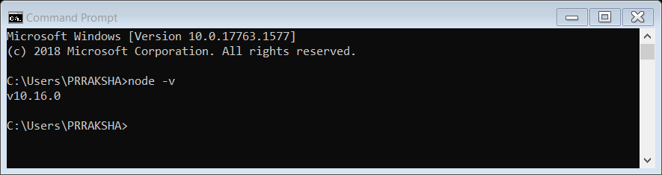
NodeJS Installation – nodejs-v10.16.0

If it is not already installed then it can be downloaded from here Node.js (v10.16.0)
Note: - For this project we need to download 10.16.0 version only.

Install Code editor
We can use any of the below code editor or IDE that supports client-side development to build your web part:
- Visual Studio Code
- Atom
- Webstorm
- Note pad++
- EditPlus

I prefer to use the “Visual Studio Code” editor, we can download it from here Visual Studio Code

Install Yeoman and gulp
Now, we need to install the Yeoman and gulp package – Open “node.js command prompt” or “PowerShell” and run the below command. npm install -g yo gulp

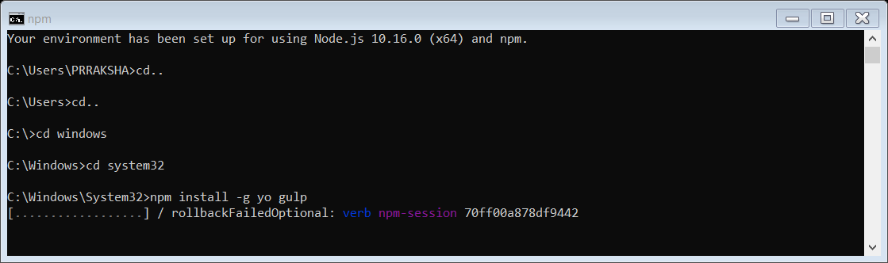
npm install -g yo gulp – Installation

This will take sometimes around 2 to 3 minutes, after that, we will get the below message on the successful installation – “Everything looks all right”.
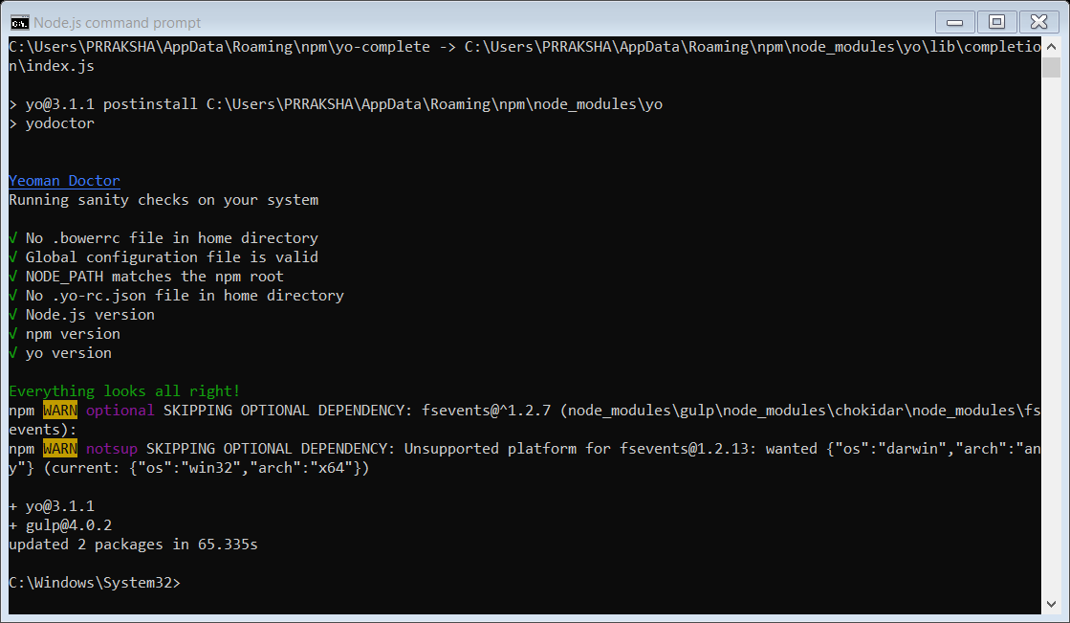
npm install -g yo gulp – Installation – success message

Note: The above “npm install -g yo gulp” command is used to import NPM packages YO and GULP

Install Yeoman SharePoint generator
This package is needed for the SharePoint web part project development using SPFx – this is a scaffolding for the project – we need to run the below command in the windows command-line tool or node JS command-line tool or in PowerShell.
npm install -g @microsoft/generator-sharepoint
- npm install gulp yo @microsoft/generator-sharepoint --global

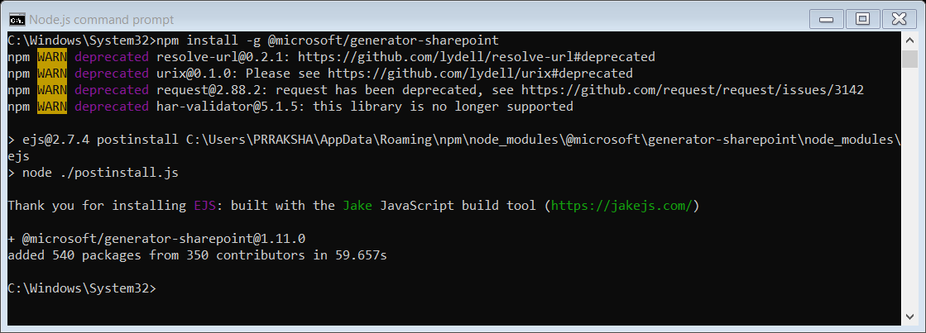
Install Yeoman SharePoint generator

Install Trusting the self-signed developer certificate
We need to run the below command in the command prompt or PowerShell window or Node JS command line. This is one time set up to trust the certificate which can be executed before started developing the project or during the first build of the project.
gulp trust-dev-cert

Postman and Fiddler (Optional)
Fiddler is an HTTP debugging proxy server application. It captures HTTP and HTTPS traffic and logs it for the user to review. You can get fiddler from here Fiddler

Postman can be used to test SharePoint’s REST service endpoints and verify the returned data and request headers. We can get Postman from Postman
Download and Install below both application also.

SharePoint Online Management Shell and SharePoint Online Client Components SDK

https://www.alitajran.com/unable-to-install-nuget-provider-for-powershell/
https://docs.microsoft.com/en-us/powershell/module/packagemanagement/install-packageprovider?view=powershell-7.1

npm install
npm install gulp
npm install -g yo gulp
npm install -g @microsoft/generator-sharepoint
npm install gulp yo @microsoft/generator-sharepoint –global

demstls-1\src\webparts\demstlc\components\TeamLeaders.tsx
private TeamLeadersImages(): void {
sp.setup({
ie11: true,
spfxContext: this.props.context
});

React-list-form\src\wepparts\listform\components\ListForms.tsx

gulp bundle --ship
gulp package-solution --ship

Final Package for Apps for SharePoint
Please create following list before deploying any package:
- FAQs
- QuickLinks
- TeamLeaders
- Need to create 1 public view with name “EditView” and make these 2 hyperlink columns (EditForm and Display).

Package Installation:-

quickpack.sppkg
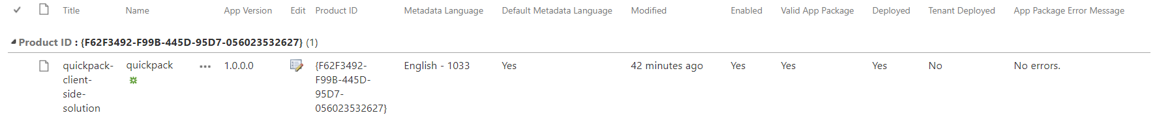
It is used to create “Tiles” and “TeamLeaders” in Home page. It’s required to add this app in site content after uploading to Apps for SharePoint.

zna-spfx-solution.sppkg

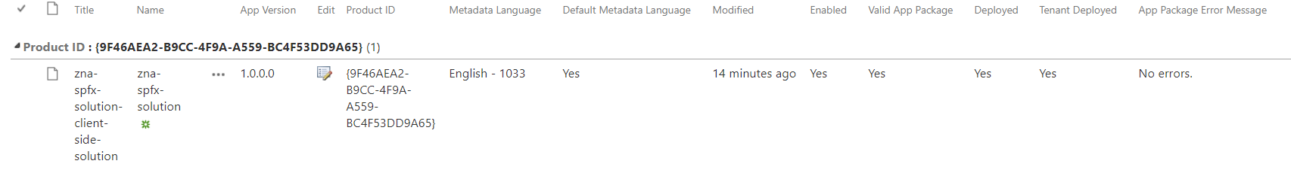
It is used for header and footer of Home page along with UI adjustment

react-form-webpart.sppkg

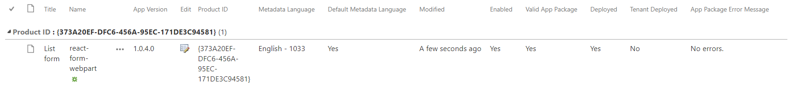
It is used to create “ListForms” for View/Edit/New page. It’s required to add this app in site content after uploading to Apps for SharePoint.
Also deploy your assets of SPPKG in Site Assets to SharePoint.

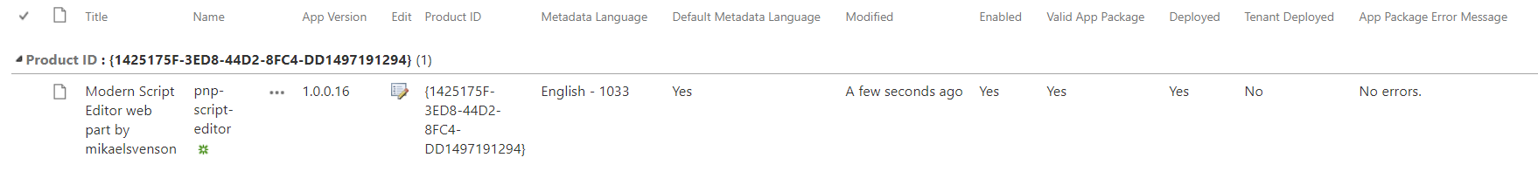

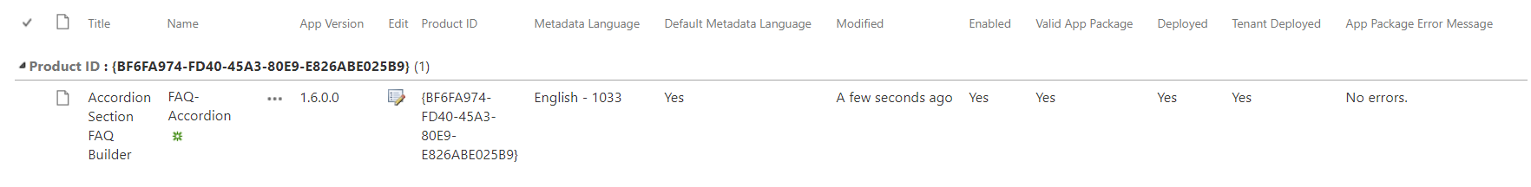

https://www.microsoft.com/en-us/download/details.aspx?id=35491 SharePoint Designer 2013

https://support.shortpoint.com/support/solutions/articles/1000271557-prerequisite-1-setup-site-collection-app-catalog-spfx-in-office-365

Create the Web part project

Create First Hello World Client Web part

Before moving forward, ensure that the SharePoint Framework development environment is ready.

Spin up Node.js command prompt using which we will be creating the web part project structure.

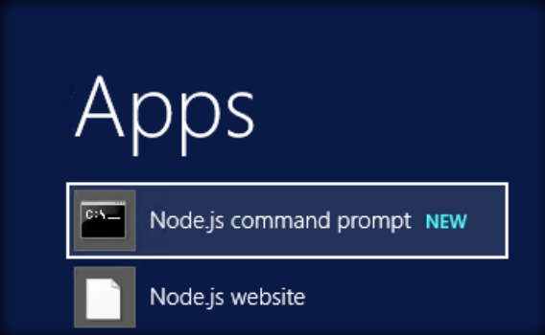
We can create the directory where we would be adding the solution using the below command:
md ClientWebPart-HelloWorld

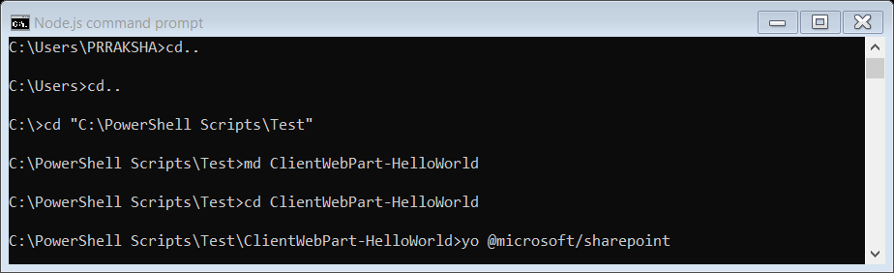
Let’s move to the newly created working directory using the command:
cd ClientWebPart-HelloWorld
We will then create the client web part by running the Yeoman SharePoint Generator:
yo @microsoft/sharepoint

This will display the prompt which we will have to fill up so as to proceed with project creation,
● What is your solution name? : Accept the default client-web-part-hello-world as your solution
name and choose Enter.
● Where do you want to place your files : Use Current Folder
● What framework would you like to start with : Select “No javaScript web framework” for the
time being as this is a sample web part

● What is your webpart name: Go on and press enter to accept the default Web part name as
HelloWorld
● Go on and press enter to accept the default Web part description as HelloWorld description

Yeoman has started working on the creation of the project. It will install the required dependencies
and scaffold the solution files for the HelloWorld web part which will take some time to complete. Once
completed, we will get a Congratulations message.

https://docs.microsoft.com/en-us/sharepoint/dev/spfx/set-up-your-development-environment
https://global-sharepoint.com/sharepoint-online/sharepoint-framework-spfx-development-environment-setup-step-by-step/
https://docs.microsoft.com/en-us/sharepoint/dev/spfx/web-parts/guidance/use-sp-pnp-js-with-spfx-web-parts
https://docs.microsoft.com/en-us/powershell/sharepoint/sharepoint-pnp/sharepoint-pnp-cmdlets?view=sharepoint-ps
https://www.c-sharpcorner.com/article/build-and-deploy-the-client-side-web-part-spfx-in-sharepoint-online/

https://demoperform1.sharepoint.com/sites/RetailAgencyProcessing_RenewalLog/Lists/Retail%20%20Agency%20Processing%20_Renewal%20Log/DispForm.aspx?ID=[ID]

https://demoperform1.sharepoint.com/sites/OrgSite/Lists/Org/EditView.aspx

